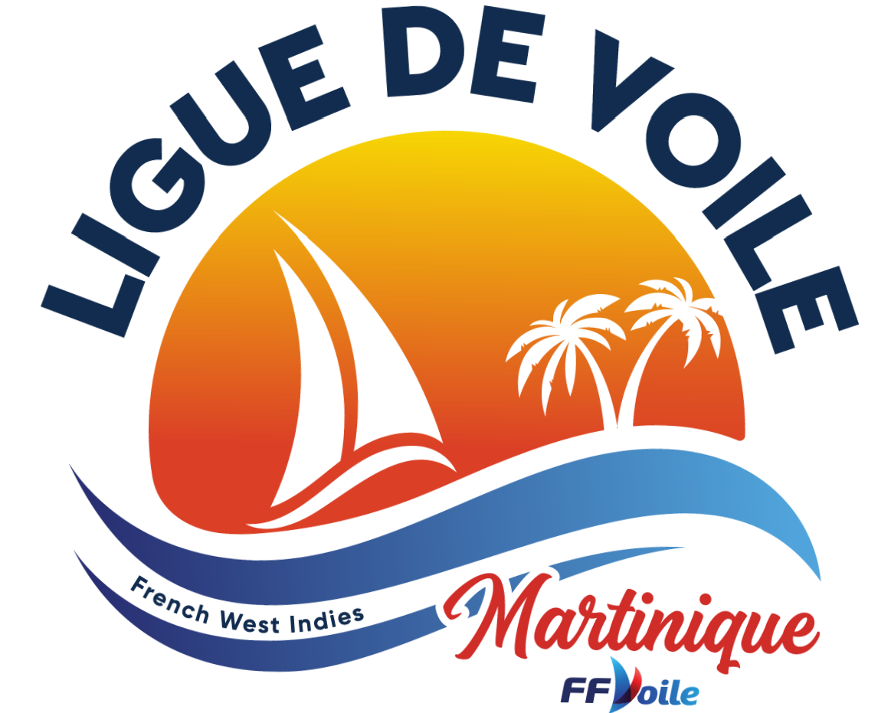

ENTRY FORM
Schoelcher Sailing week 10th to 13th February 2024 Organising authority : Cercle Nautique de Schoelcher
Identity | Skipper | Crew
Name
Surname
DATE of Birth
ADDRESS
PHONE NUMBER
EMAIL
National Letter and Sail Number
Country

Optimist Benjamin |  | Sunfish
Optimist Minime |  | Bic 293
ILCA 4 |  | Interserie Catamaran
ILCA 6 |  | I Q Foil |  |  | Rating
ILCA 7 |  | Windfoil

PARENTAL  PERMISION  (for minors)  Signature followed by father, mother, or tutor | HELMSAN | MEMBER of TEAM
 | I allow my son / my daughter to take part to the contest indicated here and free the organizing committee from any responsibility concerning risks coming with his / her participation  Write “Read and approved”  Date…………………………….. …………… Signature | I allow my son / my daughter to take part to the contest indicated here and free the organizing committee from any responsibility concerning risks coming with his / her participation  Write “Read and approved”  Date…………………………….. …………… Signature

THIS FORM MUST BE SIGNED

I agree to be bound by ISAF Rules, the Sailing Instructions and Class Rules. I understand that the organizing committee accept no responsibility of loss of life, personal injury, or damage to way vessel or equipment. I hold and will produce a valid insurance certificate. My
crew members are aware of these undertakings.

Date :…………………………………….. ………………Signature :………………

